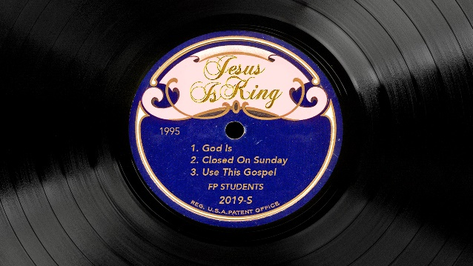

**Jesus Is King – “Use this gospel”**

**LIFE/INTRO QUESTIONS**

What were your highs and lows of the last week?

**CONNECTION QUESTION**

* Have you ever felt like the world was trying to separate you from your faith? If so, how did you respond?
* Has there ever been a time in your life where you came up against something and you remembered a scripture that helped you through it?

**Sermon in a Sentence**

* If you know your weapons, you’ll walk in victory

**SCRIPTURE**

* Matthew 4:1-11

Then Jesus was led by the Spirit into the wilderness to be tempted by the devil.**2**After fasting forty days and forty nights, he was hungry. **3**The tempter came to him and said, “If you are the Son of God, tell these stones to become bread.” **4**Jesus answered, “It is written: ‘Man shall not live on bread alone, but on every word that comes from the mouth of God.’” **5**Then the devil took him to the holy city and had him stand on the highest point of the temple. **6**“If you are the Son of God,” he said, “throw yourself down. For it is written: “‘He will command his angels concerning you, and they will lift you up in their hands, so that you will not strike your foot against a stone.’” **7**Jesus answered him, “It is also written: ‘Do not put the Lord your God to the test.’” **8**Again, the devil took him to a very high mountain and showed him all the kingdoms of the world and their splendor. **9**“All this I will give you,” he said, “if you will bow down and worship me.” **10**Jesus said to him, “Away from me, Satan! For it is written: ‘Worship the Lord your God, and serve him only.’” **11**Then the devil left him, and angels came and attended him.

**DISCUSSION QUESTIONS**

* When you encounter hard times in life, how do you typically respond?
* What was Jesus’ response to the temptations of the enemy?
* How can we apply Jesus’ response to our life?

**LIFE APPLICATION**

* What are some creative ways that you can memorize scripture to be prepared to call on them when tough times come your way?

**TAKE IT OUT**

* We will not have fpStudents over Thanksgiving break November 27th